**Report 3 support vector machines**

Willem Melis

[1 Support vector machines for regression 4](#_Toc454318338)

[1.1 Liner PCA 4](#_Toc454318339)

[1.2 Nonlinear PCA decrease PCA components 4](#_Toc454318340)

[1.3 Nonlinear PCA Increase PCA components 5](#_Toc454318341)

[1.4 Tuning the hyper parameters 5](#_Toc454318342)

[2 Handwritten digit denoising 6](#_Toc454318343)

[3 Spectral clustering 6](#_Toc454318344)

[3.1 Data clustered 6](#_Toc454318345)

[3.2 Kernel matrix (similarity measure) 7](#_Toc454318346)

[3.3 Changing sigma 8](#_Toc454318347)

[3.3.1 Data 3d plot 8](#_Toc454318348)

[3.3.2 Kernel matrix 8](#_Toc454318349)

[3.4 Fixed-size LS-SVM 10](#_Toc454318350)

[3.4.1 Subset of datapoints 10](#_Toc454318351)

[3.4.2 Approximation of feature space mapping 10](#_Toc454318352)

[3.4.3 Fixed size lssvm vsL0-approximation 11](#_Toc454318353)

[4 Homework problem: Digits 12](#_Toc454318354)

[4.1 What happens if sigma is higher than the suggested value 12](#_Toc454318355)

[5 Homework problem: shuttle 13](#_Toc454318356)

[6 Homework problem: California 14](#_Toc454318357)

[Figure 1‑1 lineair PAC analysis default parameters 4](#_Toc454318625)

[Figure 1‑2 1 PCA component 4](#_Toc454318626)

[Figure 1‑3 2 PCA components 4](#_Toc454318627)

[Figure 1‑4 3 PCA components 4](#_Toc454318628)

[Figure 1‑5 4 PCA components 4](#_Toc454318629)

[Figure 1‑6 20 pca components 5](#_Toc454318630)

[Figure 2‑1 left is nonlinear, first PC’s right is linear 6](#_Toc454318631)

[Figure 3‑1 spectral clustering 6](#_Toc454318632)

[Figure 3‑2 kernel marix before and after sort (black=low; white=high) 7](#_Toc454318633)

[Figure 3‑3 data project on last 2 of the first 3 eigenvectors (x-axis=second; y-axis=tirth) 7](#_Toc454318634)

[Figure 3‑4, 3d scatter plot data, sigma=0,001 8](#_Toc454318635)

[Figure 3‑5, 3d scatter plot data, sigma=0,005 8](#_Toc454318636)

[Figure 3‑6, 3d scatter plot data, sigma=0,01 8](#_Toc454318637)

[Figure 3‑7, 3d scatter plot data, sigma=0,2 8](#_Toc454318638)

[Figure 3‑8 kernel matrix, sig2=0.001 9](#_Toc454318639)

[Figure 3‑9 kernel matrix, sig2=0.005 9](#_Toc454318640)

[Figure 3‑10 kernel matrix, sig2=0.005 9](#_Toc454318641)

[Figure 3‑11 kernel matrix, sig2=0.2 9](#_Toc454318642)

[Figure 3‑12 output fixedsize\_script1.m 10](#_Toc454318643)

[Figure 3‑13 optimized subset for different sigma values 10](#_Toc454318644)

[Figure 3‑14 10](#_Toc454318645)

[Figure 3‑15 11](#_Toc454318646)

[Figure 3‑16 11](#_Toc454318647)

[Figure 3‑17 11](#_Toc454318648)

[Figure 4‑1 eigenvec simga=0.7 12](#_Toc454318649)

[Figure 4‑2 eigenvec sigma=7 12](#_Toc454318650)

[Figure 4‑3 lineair sigma=0.7 12](#_Toc454318651)

[Figure 4‑4 lineair sigma=7 12](#_Toc454318652)

[Figure 4‑5 RBF sigma=0.7 12](#_Toc454318653)

[Figure 4‑6 RBF sigma=7 12](#_Toc454318654)

[Figure 5‑1 number of support vectors shuttle 13](#_Toc454318655)

[Figure 5‑2 time taken shuttle 13](#_Toc454318656)

[Figure 5‑3 error comparison shuttle 13](#_Toc454318657)

[Figure 6‑1 number of support vectors California 14](#_Toc454318658)

[Figure 6‑2 time taken California 14](#_Toc454318659)

[Figure 6‑3 error comparison California 14](#_Toc454318660)

# Support vector machines for regression

## Liner PCA

When we do linear PCA analysis then the maximum amount of PCA components we can get is equal to the dimension of the points. A 2 dimensional point can be perfectly represented by 2 orthogonal components. The non-linear PCA projects its points onto an feature space. This feature space could be infinite dimensional, which makes it possible to get an infinite amount of PCA components.



Figure 1‑1 lineair PAC analysis default parameters

## Nonlinear PCA decrease PCA components

If we lower the amount of PCA components then the model is not flexible enough to reproduce the data.

|  |  |
| --- | --- |
| Figure ‑ 1 PCA component | Figure ‑ 2 PCA components |
| Figure ‑ 3 PCA components | Figure ‑ 4 PCA components |

## Nonlinear PCA Increase PCA components

If there are too many pca components we do get problems as the PCA model is so flexible is reproduces the noise. This is not what we want, it even takes longer to calculate and takes memory space.



Figure ‑ 20 pca components

## Tuning the hyper parameters

The most straight forward way to tune the hyper parameters is to define a cost function. That represents the error. And then recalculate the PCA analysis and iteratively improve the hyper parameters. This could give us a local optimum off course nothing more.

# Handwritten digit denoising

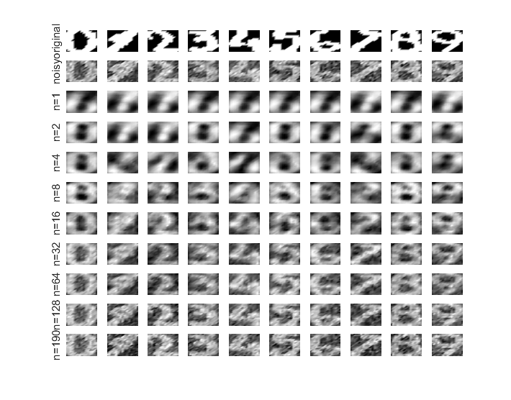

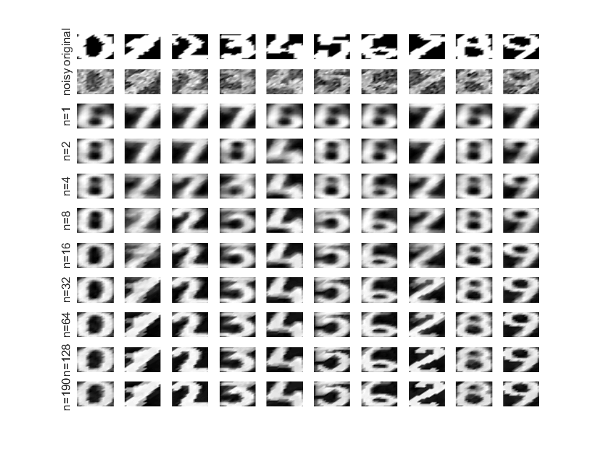

Figure 2‑1 left is nonlinear, first PC’s right is linear

The linear case on the left does not really work all that well. With a low amount of PC’s we get a very vague picture. The noise is gone, but our information Is partially gone with it. This is very unfortunate, a bit of Gaussian filter and median filter before doing the PCA could significantly improve the performance.

The kernel PCA is way better than the linear when there are enough PC’s but, if it go’s wrong it’s just terrible. The number 7 becomes the number 2. I think this also has to do with the translation and rotation of 7.

# Spectral clustering

## Data clustered



Figure 3‑1 spectral clustering

We can see in Figure 3‑1 the original data on the left, and the clustered data on the right. It is not intuitively clear how one would cluster there into these two groups.

## Kernel matrix (similarity measure)



Figure 3‑2 kernel marix before and after sort (black=low; white=high)

We know that the kernel matrix acts as a similarity measure, On the left side of Figure 3‑2 we can see the kernel matrix for the unsorted data. On the right side we can see the same kernel matrix but for the sorted. Notice how the right side has 2 “islands” which means that only a part of the data is similar to a itself. The first half of the row and first half of the columns is related to the first half of the row and the first half of the columns.

We can clearly see that there is clustering in this data. The spectral clustering has revealed the two clusters even though they were not clearly visible from the start.



Figure 3‑3 data project on last 2 of the first 3 eigenvectors (x-axis=second; y-axis=tirth)

On Figure 3‑3 it is clear that we took the second eigenvector to split the data. The negative part is purple and the positive part is yellow.

## Changing sigma

### Data 3D plot

|  |  |
| --- | --- |
| Figure 3‑4, 3d scatter plot data, sigma=0,001 | Figure 3‑5, 3d scatter plot data, sigma=0,005 |
| Figure 3‑6, 3d scatter plot data, sigma=0,01 | Figure 3‑7, 3d scatter plot data, sigma=0,2 |

If Sigma is small enough, the clustering will be done between the two rings. The rings itself will be the cluster. But if sigma is wide enough we will get clustering with overlap op the rings. The two clusters can have data from both rings. The reason for this is because a small sigma will not measure much similarity, this is nicely illustrated on the kernel matrices.

### Kernel matrix



Figure ‑ kernel matrix, sig2=0.001



Figure ‑ kernel matrix, sig2=0.005



Figure ‑ kernel matrix, sig2=0.005



Figure 3‑11 kernel matrix, sig2=0.2

It is very clear from the different kernels that if sigma is very small it will hardly find any similarity, and when sigma is very large it will find way to much similarity. In both extreme cases we get bad results, which are displayed on the clustered figure. (Figure 3‑4, Figure 3‑5, Figure 3‑6 and Figure 3‑7)

## Fixed-size LS-SVM

### Subset of datapoints

We will try to approximate the feature space with a small subset of the data. The data should be chose so that we get the best representation of the feature space off course. This can be realized by using an entropy measurement.



Figure 3‑12 output fixedsize\_script1.m

If sigma is very small the points will be less spread out then with a larger sigma. But if sigma is very large it will only take points at the border. A sigma2 of 0.1 seems to be a good choice in this example.

|  |  |  |
| --- | --- | --- |
|  |  |  |
|  |  |  |

Figure 3‑13 optimized subset for different sigma values

### Approximation of feature space mapping



Figure 3‑14

The algorithm converges to only a few vectors that represent the feature space. With this we can approximate the feature space. The vectors itself should optimize the feature space criterium.

The tree vectors are independent, so these form to getter an invertible matrix.

### Fixed size lssvm vs L0-approximation

It’s very clear from Figure 3‑15 that the FS-LSSVM clearly produces much more support vectors, while the L0-approximation that hardly needs any support vectors. And with these few support vectors the L0 method still has an similar error then the fixed window method.

The time taken by the 2 approaches is nearly the same. But the amount of support vectors with the L0 method is clearly a lot better. This means that in this case we would prefer the L0 method was it gives us a good result with very few support vectors.

|  |  |
| --- | --- |
| Figure ‑ | Figure ‑ |



Figure ‑

# Homework problem: Digits

## What happens if sigma is higher than the suggested value

On the left side we can see the default value for sigma (0.7) and on the right we can see a higher value for sigma. The eigenvectors already show what is happening. We can see that the eigenvectors with a higher sigma are vague. And clearly contain a lot of noise themselves.

The linear case still produces a decent result, knowing that the result isn’t all that good with sigma=0,7. But the case with the RBF kernel is just terrible, the eigenvectors with noise are ruining the result. (this is visible on )

|  |  |
| --- | --- |
| Figure ‑ eigenvec simga=0.7 | Figure ‑ eigenvec sigma=7 |
| C:\Users\Willem\AppData\Local\Microsoft\Windows\INetCache\Content.Word\sig_0_7_lin.png  Figure ‑ lineair sigma=0.7 | C:\Users\Willem\AppData\Local\Microsoft\Windows\INetCache\Content.Word\sig_7_lin.png  Figure ‑ lineair sigma=7 |
| C:\Users\Willem\AppData\Local\Microsoft\Windows\INetCache\Content.Word\sig_0_7_non_lin.png  Figure ‑ RBF sigma=0.7 | C:\Users\Willem\AppData\Local\Microsoft\Windows\INetCache\Content.Word\sig_7_non_lin.png  Figure ‑ RBF sigma=7 |

# Homework problem: shuttle

The parameter were determined with directional search. The Fixed size LSSVM produces always the same amount of support vectors and the number is quiet high compared to the L0 LSSVM. But the fewer support vectors in the L0 LSSVM results in a higher error bar off course. The time taken is about the same, but if the application allows for the error bar from the L0 norm this is the best approach. If not then the FS-LSVM is the way to go

|  |  |
| --- | --- |
| C:\Users\Willem\AppData\Local\Microsoft\Windows\INetCache\Content.Word\fig2.png  Figure 5‑1 number of support vectors shuttle | C:\Users\Willem\AppData\Local\Microsoft\Windows\INetCache\Content.Word\fig3.png  Figure ‑ time taken shuttle |
| C:\Users\Willem\AppData\Local\Microsoft\Windows\INetCache\Content.Word\fig1.png  Figure ‑ error comparison shuttle | |

# Homework problem: California

With this dataset we get the same amount of support vectors for both approaches. This off course means that the error bar will be about the same. So the Fixed window size approach is clearly better as it requires less time to calculate.

Sometimes the fixed window size method could also have less support vectors then the L0 method. This is not the case here, but if that were the case then the L0 method would have a better error bar.

|  |  |
| --- | --- |
| C:\Users\Willem\AppData\Local\Microsoft\Windows\INetCache\Content.Word\fig2.png  Figure 6‑1 number of support vectors California | C:\Users\Willem\AppData\Local\Microsoft\Windows\INetCache\Content.Word\fig3.png  Figure ‑ time taken California |
| C:\Users\Willem\AppData\Local\Microsoft\Windows\INetCache\Content.Word\fig1.png  Figure ‑ error comparison California | |

# Homework digits extra

## Change the sigmafactor in log scale

The following figures are with a sigma2 on log scale: logspace(-2,2,4)

|  |  |
| --- | --- |
| C:\Users\Willem\AppData\Local\Microsoft\Windows\INetCache\Content.Word\fig1_2.png  Figuur ‑ sigmafactor=1 | C:\Users\Willem\AppData\Local\Microsoft\Windows\INetCache\Content.Word\fig2_2.png  Figuur ‑ sigmafactor=2 |
| C:\Users\Willem\AppData\Local\Microsoft\Windows\INetCache\Content.Word\fig3_2.png  Figuur ‑ sigmafactor=3 | C:\Users\Willem\AppData\Local\Microsoft\Windows\INetCache\Content.Word\gig4_1.png  Figuur ‑sigmafactor=4 |

It is very clear that a very small sigma gives very clear numbers but often wrong number and a very large sigma gives very vague pictures but they are not drastically wrong like with the small sigma. An large sigma is similar to the linear PCA.

## Difference linear and kernel PCA



Figuur 7‑5 left is kernel pca right is linear PCA

The difference between linear and kernel PCA is that kernel PCA can detect more complex shapes. Which means that it can reconstruct an digit very well with only a few principle components. Because linear PCA is linear it needs more principle components to build an equivalent digit. This why when kernel PCA is so binary, you either get a good result or bad result there is little middle ground.

For example: The number seven in the picture is vague with the linear PCA, but its still a seven. The kernel PCA however made it a clear two.